Avg. discrepancy and Avg. abs. error

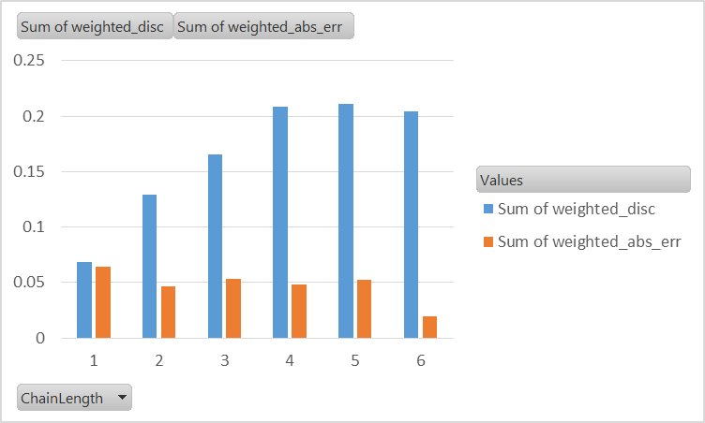

Problem in chains of length 1.

Histogram of discrepancy levels (count of individual chains) segmented by chain length, in 2nd period